Assignment -3

|  |  |
| --- | --- |
| Student Name | T.Madhuvarshini |
| Team ID: | PNT2022TMID23716 |
| Project Name | Smart Fashion Recommender Application |
| Maximum Marks | 2 Marks |

Question -1:

1.Create a Bucket in IBM object storage.

Solution:

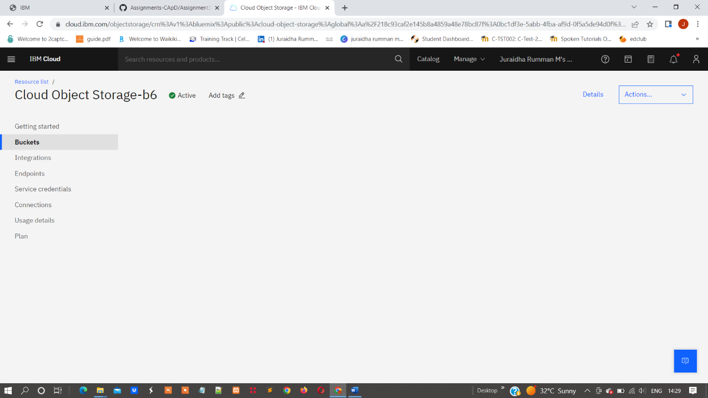

Question -2:

2.Upload an 5 images to ibm object storage and make it public. write html code to displaying all the 5 images.

Solution:

<DOCTYPE html>

<html>

<head>

<title>First Website</title>

</head>

<body>

<h1>This is Images</h1>

<img src="./dog.png" alt="">

</body>

<body>

<img src="./kids.png" alt="">

</body>

<body>

<img src="./mango.png" alt="">

</body>

<body>

<img src="./key.png" alt="">

</body>

<body>

<img src="./photo.png" alt="">

</body>

</html>

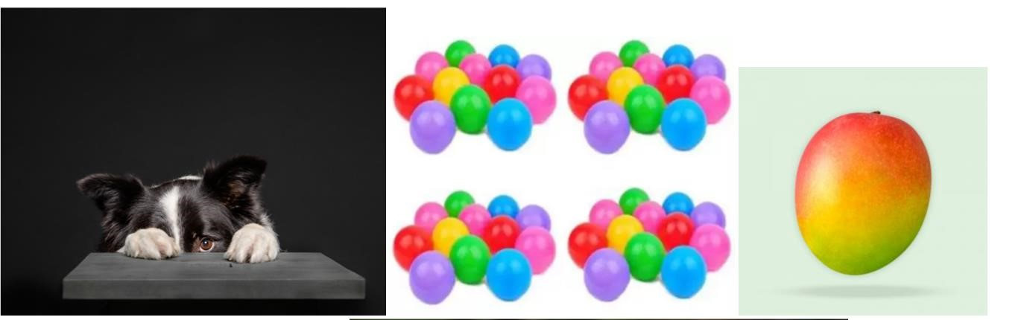

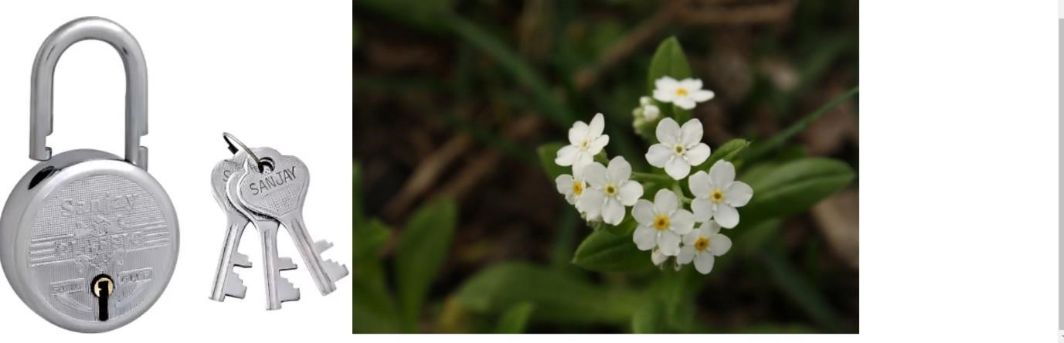

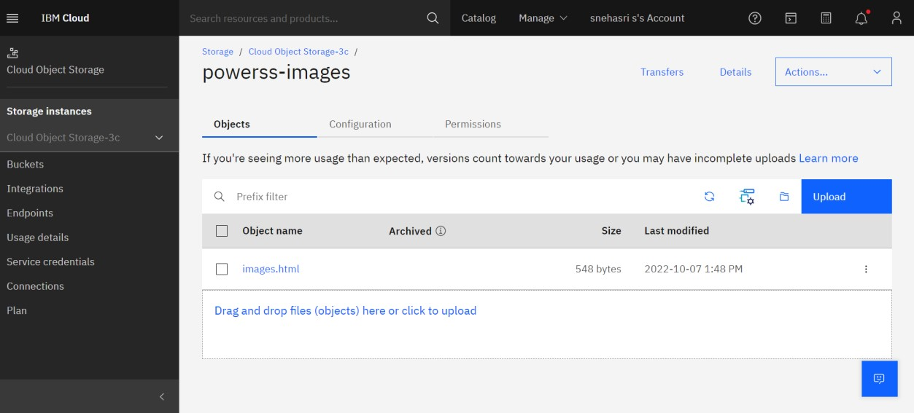

Question -3:

3.Upload a css page to the object storage and use the same page in your HTML code.

Solution:

<DOCTYPE html>

<html>

<head>

<title>First Website</title>

</head>

<body>

<h1>This is a heading</h1>

<p>This is all images</p>

<img src="./dog.png" alt="">

</body>

<body>

<img src="./kids.png" alt="">

</body>

<body>

<img src="./photo.png" alt="">

</body>

<body>

<img src="./key.png" alt="">

</body>

<body>

<img src="./mango.png" alt="">

</body>

</html>

<!DOCTYPE html>

<html Lang ="en">

<head>

<meta charset="UTF-8>

<meta http-equiv="X-UA-compatible"content="IE=edge">

<meta name="viewport" content ="width=device-width,initial-scale=1.0">

<link rel= "stylesheet"

<title>document</title>

</head>

<body>

<label for="files">select multiple files</label>

<input type="file" id="files" multiple="multiple" accept="image/jpeg,image/png,image/jpg"> <output id="result">

<script src="script.js"></script>

</body>

<files.length;i++)[ if(! files [i].type.match("image"))continue; const pic reader new filereader():

pic reader.addeventlistener("load",function(event){ const picfile = event.target; const div = document.createelement("div");

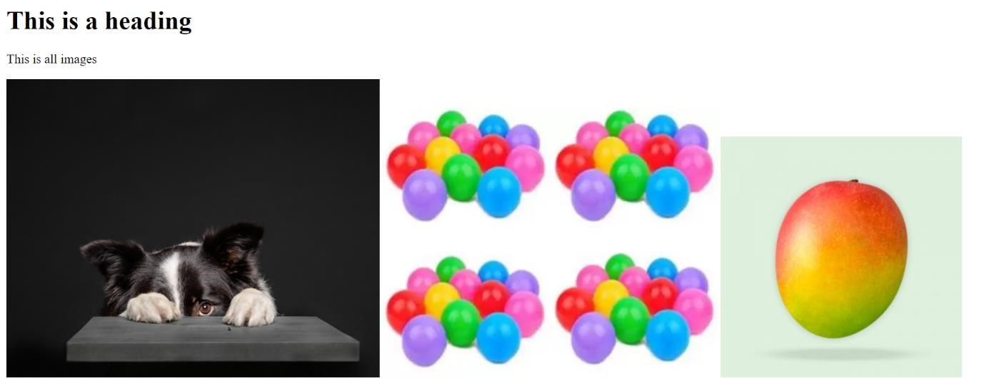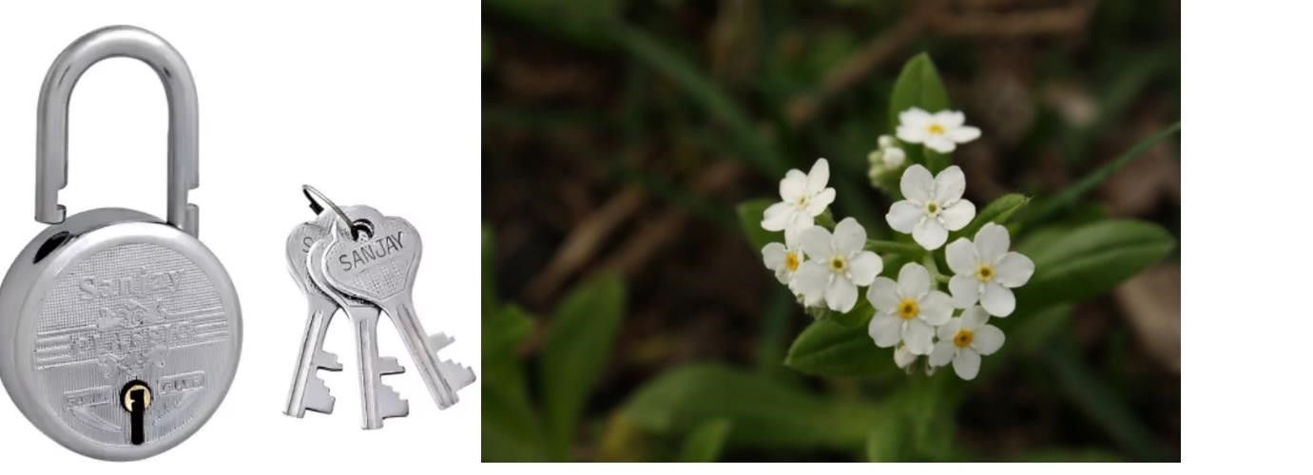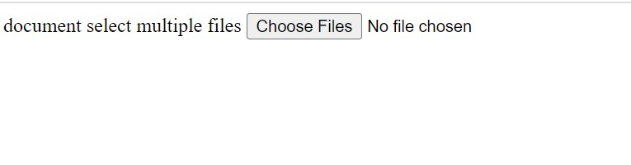

Question -4:

4.Design a chatbot using IBM Watson assistant for hospital. Ex: User comes with query to know the branches for that hospital in your city. Submit the web URL of that chat bot as a assignment.

Solution: Question -5: 5.Create Watson assistant service with 10 steps and use 3 conditions in it. Load that script in HTML page. Footer

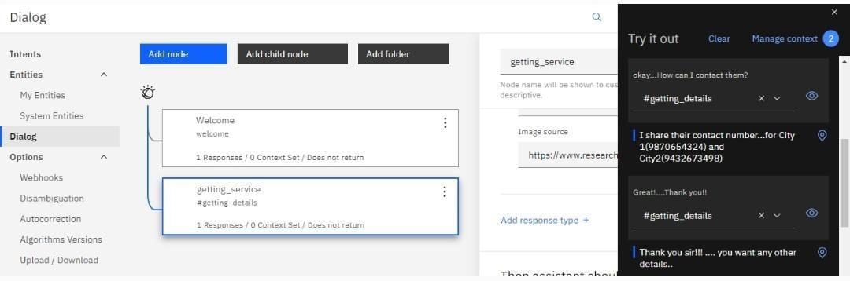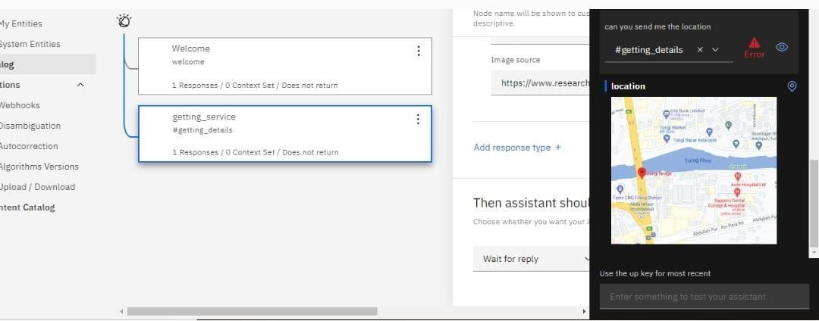

Solution:

{

"intents": [

{

"intent": "email_data",

"examples": [

{

"text": "Can you email it to @email"

},

{

"text": "Can you email this file to @sys-person"

},

{

"text": "Can you forward this data to @sys-person"

},

{

"text": "Can you forward this file to @sys-person?"

},

{

"text": "Can you send this data to @sys-person"

},

{

"text": "Can you send this to @sys-person"

},

{

"text": "Email me this data"

},

{

"text": "Email the data at @email"

},

{

"text": "Email the data to @email and @email"

},

{

"text": "Email this file to @sys-person"

},

{

"text": "forward it to @email"

},

{

"text": "Forward this data to @email"

},

{

"text": "Forward this data to @email and @email"

},

{

"text": "Forward this data to me by email"

},

{

"text": "Forward this file to @email"

},

{

"text": "Forward this file to my email"

},

{

"text": "Forward this file to @sys-person"

},

{

"text": "Forward this file to yara.rizk@ibm.com"

},

{

"text": "forward this to @email"

},

{

"text": "Send the data to @email, @email, and @email"

},

{

"text": "Send this data over email"

},

{

"text": "Send this data to @sys-person"

}

],

"description": "Send the data as attachment over email"

},

{

"intent": "export_csv",

"examples": [

{

"text": "create a comma separated csv file"

},

{

"text": "create a csv file"

},

{

"text": "create a csv file based on the data"

},

{

"text": "create a csv file for the query results"

},

{

"text": "create a csv file from this data"

},

{

"text": "Create a csv from the query"

},

{

"text": "create an excel file for this query"

},

{

"text": "create an excel file from this data"

},

{

"text": "create an excel file with this data"

},

{

"text": "export as csv"

},

{

"text": "export as csv file"

},

{

"text": "Export data in comma separated values"

},

{

"text": "export data to csv"

},

{

"text": "export the data"

},

{

"text": "export the data as a csv"

},

{

"text": "export the data as a csv file"

},

{

"text": "export the data as csv"

},

{

"text": "export the data as csv file"

},

{

"text": "export the data in a csv"

},

{

"text": "Export the data in csv format"

},

{

"text": "export the data to a file"

},

{

"text": "export the data to csv"

},

{

"text": "export this data to a csv file"

},

{

"text": "export this data to a file"

},

{

"text": "export to a csv file"

},

{

"text": "export to csv"

},

{

"text": "export to csv file"

},

{

"text": "export to file"

},

{

"text": "i want a csv file containing the data"

},

{

"text": "i want an excel file containing this data"

},

{

"text": "produce a csv file from the data"

},

{

"text": "produce a csv file from this data"

},

{

"text": "put the data in a csv file"

},

{

"text": "Put the data in csv"

},

{

"text": "put this data in a csv file"

},

{

"text": "save my data as csv"

},

{

"text": "save the data as csv"

},

{

"text": "save the data as csv file"

},

{

"text": "save the data in a csv"

},

{

"text": "save the data in csv file"

},

{

"text": "save the data to file"

},

{

"text": "save this data as csv"

},

{

"text": "save this data in a csv file"

},

{

"text": "save this data to a file"

},

{

"text": "save to file"

},

{

"text": "Send csv to me"

},

{

"text": "Send me a csv file"

},

{

"text": "Send me a csv file for this data"

},

{

"text": "Send me the data in excel format"

}

],

"description": "export data in csv format"

}

],

"entities": [

{

"entity": "email",

"values": [

{

"type": "patterns",

"value": "{word}@{word}.{word}",

"patterns": [

"\\b[A-Za-z0-9._%+-]+@([A-Za-z0-9-]+\\.)+[A-Za-z]{2,}\\b"

]

}

],

"fuzzy_match": false

},

{

"entity": "sys-person",

"values": [],

"fuzzy_match": true

}

],

"metadata": {

"api_version": {

"major_version": "v2",

"minor_version": "2018-11-08"

}

},

"dialog_nodes": [

{

"type": "standard",

"title": "Anything else",

"output": {

"generic": [

{

"values": [

{

"text": "I didn't understand. You can try rephrasing."

},

{

"text": "Can you reword your statement? I'm not understanding."

},

{

"text": "I didn't get your meaning."

}

],

"response_type": "text",

"selection_policy": "sequential"

}

]

},

"conditions": "anything_else",

"dialog_node": "Anything else",

"previous_sibling": "node_4_1573677581190"

},

{

"type": "event_handler",

"output": {

"generic": [

{

"values": [],

"response_type": "text",

"selection_policy": "sequential"

}

]

},

"parent": "slot_9_1573677592451",

"event_name": "focus",

"dialog_node": "handler_5_1573677592466",

"previous_sibling": "handler_7_1573677592466"

},

{

"type": "event_handler",

"parent": "slot_9_1573677592451",

"context": {

"email": "@email"

},

"conditions": "@email",

"event_name": "input",

"dialog_node": "handler_7_1573677592466"

},

{

"type": "frame",

"conditions": "#email_data",

"dialog_node": "node_4_1573677581190",

"previous_sibling": "Welcome"

},

{

"type": "slot",

"parent": "node_4_1573677581190",

"variable": "$email",

"dialog_node": "slot_9_1573677592451"

},

{

"type": "standard",

"title": "Welcome",

"output": {

"generic": [

{

"values": [

{

"text": "Hello. How can I help you?"

}

],

"response_type": "text",

"selection_policy": "sequential"

}

]

},

"conditions": "welcome",

"dialog_node": "Welcome"

}

],

"counterexamples": [],

"system_settings": {

"tooling": {

"store_generic_responses": true

},

"off_topic": {

"enabled": true

},

"disambiguation": {

"prompt": "Did you mean:",

"none_of_the_above_prompt": "None of the above"

},

"human_agent_assist": {

"prompt": "Did you mean:"

},

"spelling_auto_correct": true

},

"learning_opt_out": false,

"name": "Export-data-WA",

"language": "en",

"description": "Skill to export data"

}